***Final Exam***

***CERTIFICATE IN DATA SCIENCE AND DEEP LEARNING***

**Task 1: XML DOM Parser**

You will be developing an XML parser. There are two types of parsing methods for XML i.e. Document Object Model (DOM) and Simple API for XML (SAX). You will develop the DOM parser.

1. To begin with, you will first check if an XML document is well formed or not. A well-formed documents simply require that all elements are cleanly nested.
2. By using the List data structure (use as is or sub-class it), to create a DOM model for any XML document.

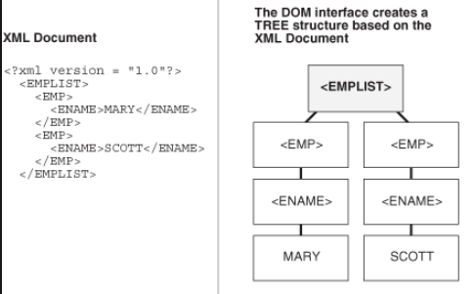

Figure 1: An XML document and its corresponding DOM

**Task 2: Human Resource Management Web Application**

You are supposed to develop a djnago based human resource management application. It should support following features:

1. SignUp and SignIn forms
2. Add / Edit / Delete employees with id, name, dob, shift, department
3. Add an attendance for a particular employee
4. Show daily and weekly attendance for each employee
5. Weekly payroll report
   1. If employee worked for more than 8 hours on a day, extra hours will be considered overtime
   2. If employee worked on Sunday, it will be counted as double time

Show regular, overtime and double time hours for each employees for the whole week